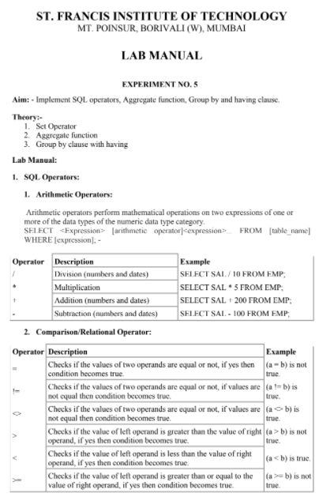

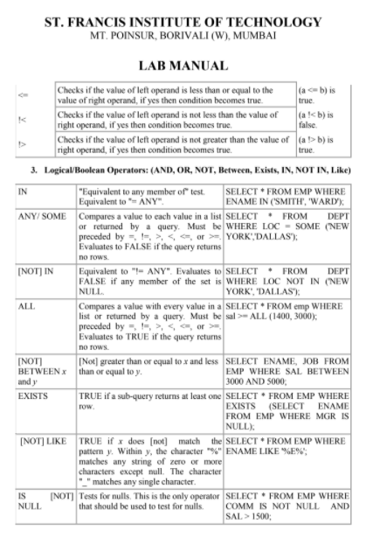

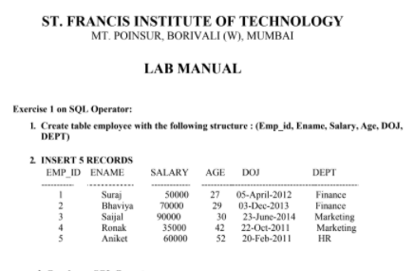

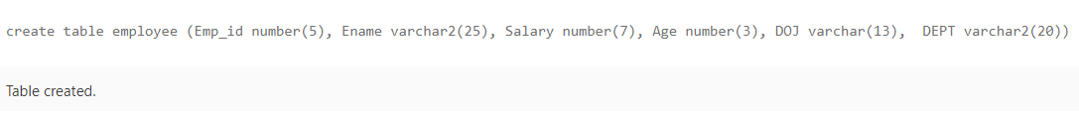

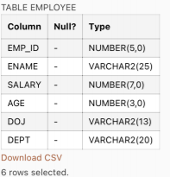



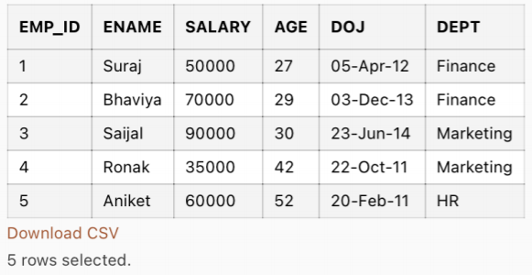

**Queries on SQL Operator:**

1. Find all employee names that have salary greater than 50000.

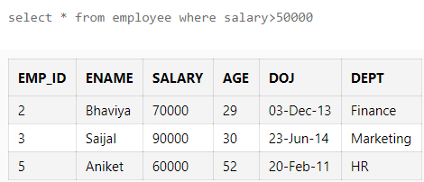

1. Give 10% raise in salary of each employee.

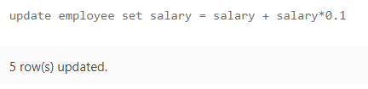

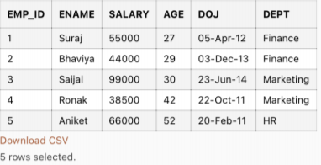

1. Give the details of employee joined from 05-april-2012 to 23-june-2014.

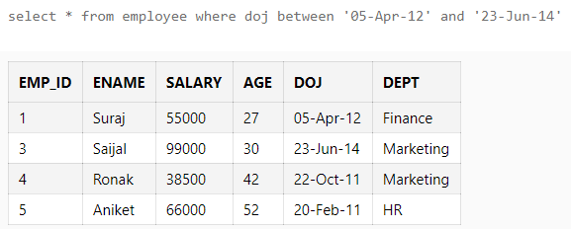

1. Find all employees who are having salary greater than 70000 and have joined after 3 dec 2013.

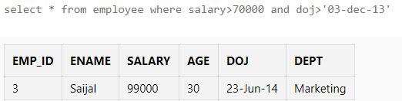

1. Find all employees with name starting with s.

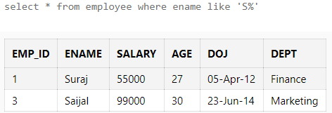

1. Find all employees who have at least one 'e' in their names.

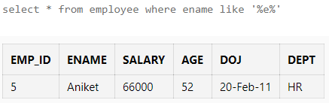

1. Find all employees with age either 29 or 30.

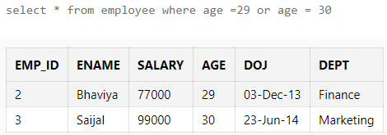

1. Find all employees who have not joined on 05-april-2012.

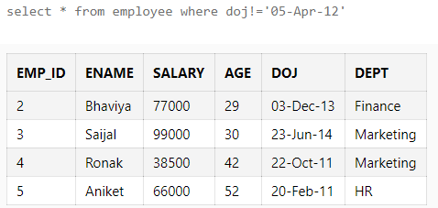

1. Alter the table by adding new column as amount deducted from salary towards tax.

Update the value of tax in the table as 20% of salary.



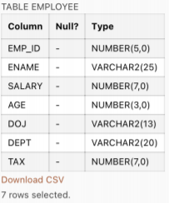

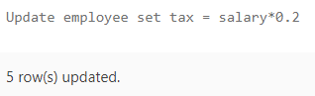

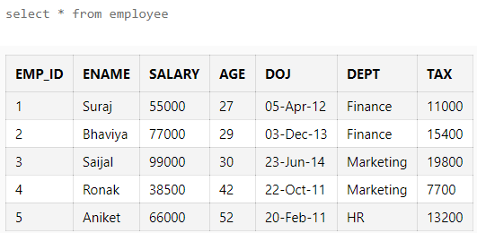

1. Calculate the net salary for each employee.

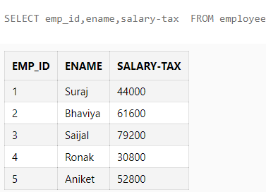

1. Find all employees whose age is greater than 25 and earns salary. (use exists clause).

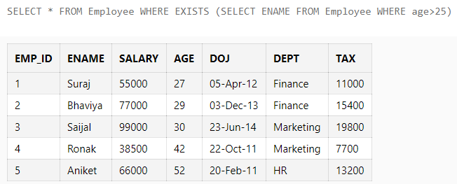

1. Find all employee names whose age is from the list given ‘25, 30, 24, 29’.

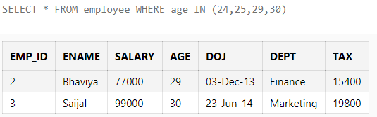

1. Find all employee names who has not joined on these dates {22-oct-201, 20-feb-2011,

03-dec-2013}.

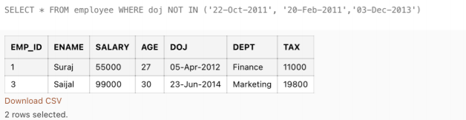

1. List all employees in descending order of their salary.

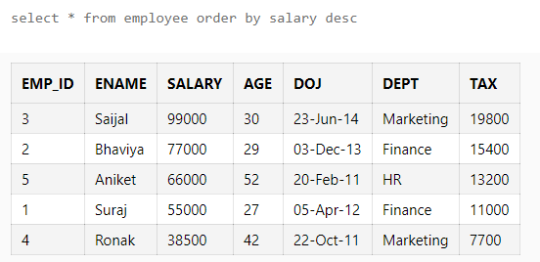

1. List all employees name in ascending order with joining date ’05-april-2012’ or after

this date.

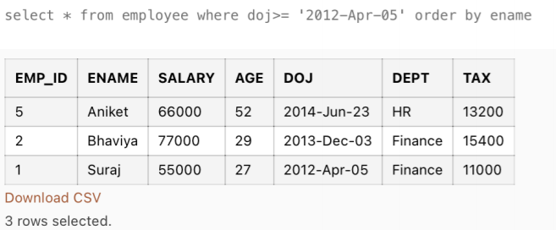

1. List the employees whose age is not null.

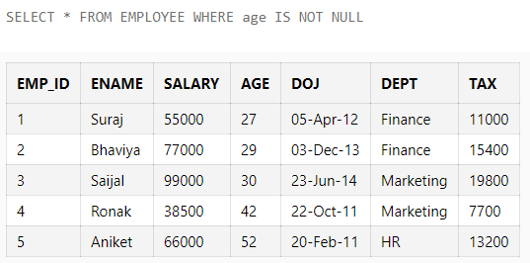

1. List the employees whose age is greater than the age of all the employees having salary

greater than 5000.

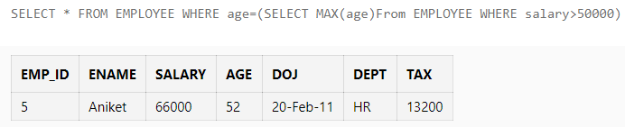

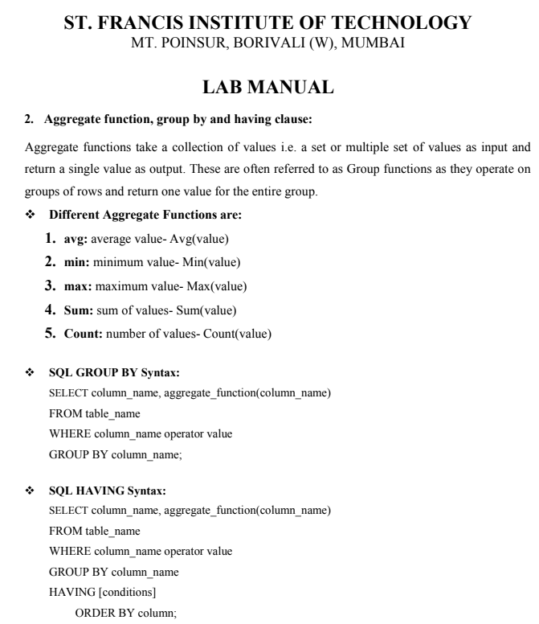

**Exercise 2 on aggregate function, group by and having clause:**

1. Find average salary of all employees for a particular department.

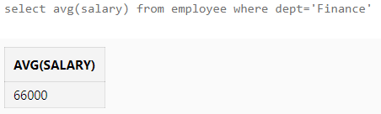

1. Find the details of that employee who has maximum salary in all departments.

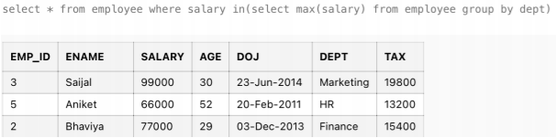

1. Find the details of employee who has minimum salary and who has joined after 23-oct-2011.

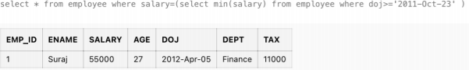

1. What are the total numbers of rows in the Employee table?

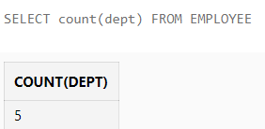

5. For all of the employees in computer department, what is the joining date of an employee

with lowest salary in that department?

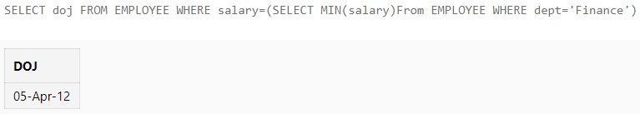

6. Display the name of each employee department wise and order it in descending order.

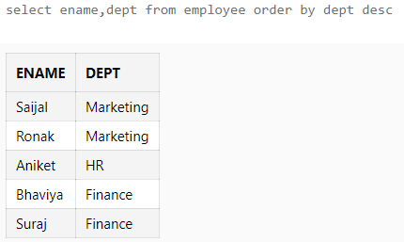

7. Find the total salary of all employees for each department.

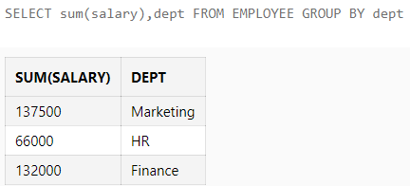

8. Find the names of all departments where the average salary of employee is more than 30,000.

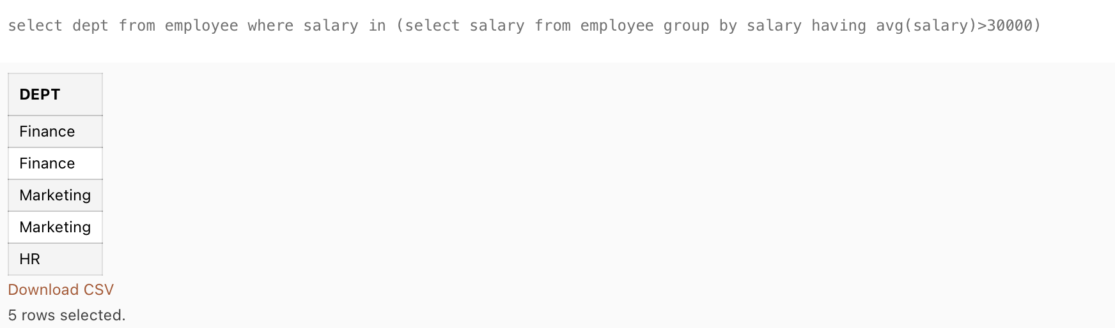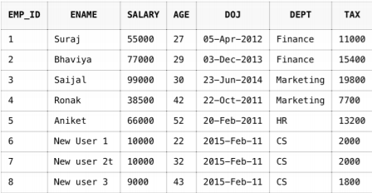

9. Sort Employee name in ascending order, and if Employee name is same, then it is sorted

Department wise in descending order.

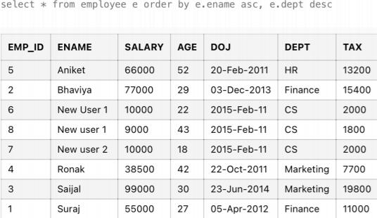

10. Count the number of Employees in each department.

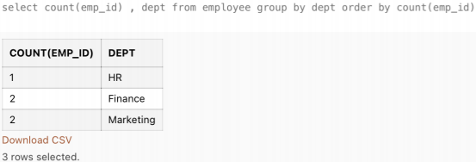

11. Display the name of Employees who have joined on the same date.

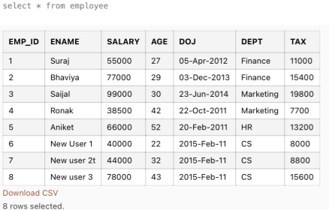

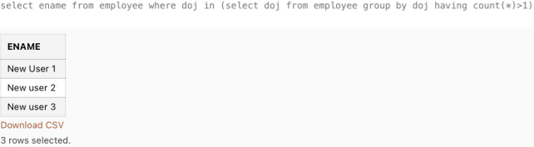

12. Display the name of employees who have less than 2 employees in a particular department.

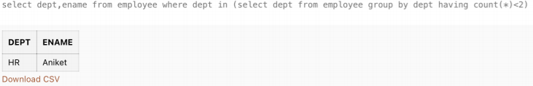

**Conclusion:** From the above experiment we are able to learn about different aggregate functions like HAVING clause and GROUP By clause. We are easily able to learn to find average, minimum, maximum, sum and count functions in SQL. The different set operators can also be learnt easily like arithmetic operators, Comparison/Relational operators, Logical/Boolean operators.